**22AIE202 – OPERATING SYSTEMS**

**LABSHEET 5**

Name : Anuvind MP

Roll no: AM.EN.U4AIE22010

--------------------------------------------------------------------------------------------------------------------------

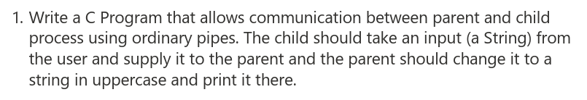

**CODE:**

#include <stdio.h>

#include <stdlib.h>

#include <unistd.h>

#include <sys/wait.h>

#include <ctype.h>

#define BUFFER_SIZE 1024

int main() {

    int pfd[2];

    char buffer[BUFFER_SIZE];

    pipe(pfd);

    pid_t pid = fork();

    if (pid == -1){

        perror("fork");

        exit(EXIT_FAILURE);}

    else if (pid == 0){

        close(pfd[0]); // Close unused read end

        printf("Enter a string: ");

        fgets(buffer, sizeof(buffer), stdin);

        write(pfd[1], buffer, sizeof(buffer));

        close(pfd[1]);} // Close write end

    else{

        close(pfd[1]); // Close unused write end

        read(pfd[0], buffer, sizeof(buffer));

        for (int i = 0; buffer[i]; i++){

            buffer[i] = toupper(buffer[i]);}

        printf("Uppercase string received from child: %s\n", buffer);

        close(pfd[0]); // Close read end

        wait(NULL);}

    return 0;}

**OUTPUT:**

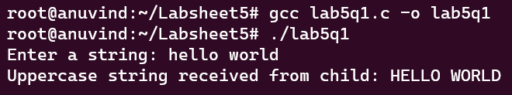

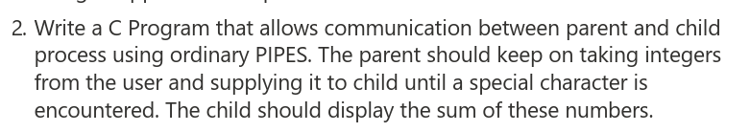

**CODE:**

#include <stdio.h>

#include <stdlib.h>

#include <unistd.h>

#include <sys/wait.h>

#include <stdbool.h>

#define BUFFER_SIZE 1024

int main(){

    int pfd[2];

    char buffer[BUFFER_SIZE];

    if (pipe(pfd) == -1){

        perror("pipe");

        return 1;}

    pid_t pid = fork();

    if (pid == -1){

        perror("fork");

        return 1;}

    else if (pid == 0){

        close(pfd[1]); // Close unused write end

        int sum = 0;

        while(1){

            read(pfd[0], buffer, sizeof(buffer));

            if (buffer[0] == '$') // Special character to indicate end

                break;

            int num = atoi(buffer);

            sum += num;}

        printf("Sum of numbers received from parent: %d\n", sum);

        close(pfd[0]); // Close read end

        exit(EXIT_SUCCESS);}

    else{

        close(pfd[0]); // Close unused read end

        printf("Enter integers (type any special characters to stop): \n");

        char input[BUFFER_SIZE];

        while(1){

            scanf("%s", input);

            write(pfd[1], input, sizeof(input));

            if (buffer[0] == '$') // Special character to indicate end

                break;}

        close(pfd[1]); // Close write end

        wait(NULL);} // Wait for child to finish

    return 0;}

**OUTPUT:**

3. Write a c program using pipes to find average of square of numbers supplied by a user using 3 processes. 1 parent and two children.

a.  Parent should continuously take integers as input from the user until a special character, square it and supply it to both children.

b.  Child #1 should find sum of these numbers, send it to the parent and exit.

c.  Child #2 should count these numbers, send them to the parent, and exit

d.  Parent on getting response from both the children should find mean of square of numbers supplied by the user by dividing the child #1's result with child 2's and give it to the user

**CODE:**

#include <stdio.h>

#include <stdlib.h>

#include <unistd.h>

#include <sys/wait.h>

int main() {

    int pc1[2], pc2[2], cp1[2], cp2[2];

    if (pipe(pc1) == -1 || pipe(pc2) == -1 || pipe(cp1) == -1 || pipe(cp2) == -1){

        perror("pipe");

        return 1;}

    pid_t child1_pid, child2_pid;

    if ((child1_pid = fork()) == -1){

        perror("Fork failed");

        return 1;}

    if (child1_pid == 0){  // Child 1 process

        close(pc1[1]);

        close(cp1[0]);

        close(pc2[0]);

        close(pc2[1]);

        close(cp2[0]);

        close(cp2[1]);

        int sum = 0, num;

        while (read(pc1[0], &num, sizeof(int)) > 0){

            sum += num * num;}

        close(pc1[0]);

        write(cp1[1], &sum, sizeof(int));

        close(cp1[1]);

        exit(0);}

    else {  // Parent process

        if ((child2_pid = fork()) == -1){

            perror("Fork failed");

            return 1;}

        if (child2_pid == 0){  // Child 2 process

            close(pc1[0]);

            close(pc1[1]);

            close(cp1[0]);

            close(cp1[1]);

            close(pc2[1]);

            close(cp2[0]);

            int count = 0, num;

            while (read(pc2[0], &num, sizeof(int)) > 0){

                count++;}

            close(pc2[0]);

            write(cp2[1], &count, sizeof(int));

            close(cp2[1]);

            exit(0);

        }

        else{  // Parent process

            close(pc1[0]);

            close(pc2[0]);

            close(cp1[1]);

            close(cp2[1]);

            int num;

            printf("Enter integers: ");

            while (scanf("%d", &num) == 1) {

                write(pc1[1], &num, sizeof(int));

                write(pc2[1], &num, sizeof(int));}

            close(pc1[1]);

            close(pc2[1]);

            int sum, count;

            read(cp1[0], &sum, sizeof(int));

            read(cp2[0], &count, sizeof(int));

            close(cp1[0]);

            close(cp2[0]);

            if (count != 0){

                float mean = (float)sum / count;

                printf("Mean of squares: %.2f\n", mean);}

            else{

                printf("No numbers were entered.\n");}

            wait(NULL);

            wait(NULL);}

    }

    return 0;}

**OUTPUT:**